Data Pre-Processing And Normal Distribution With Probability

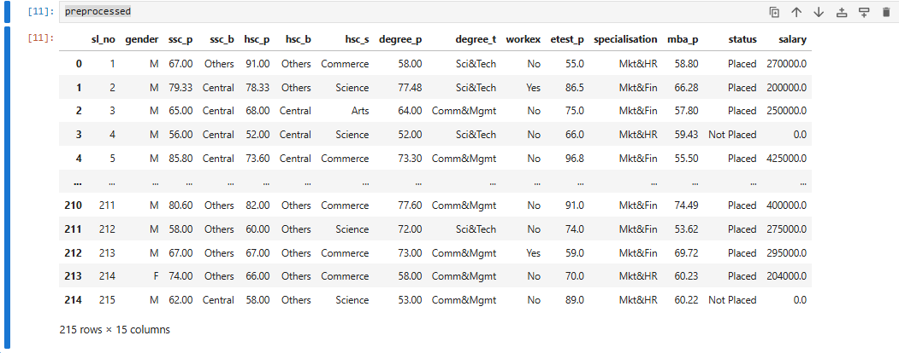
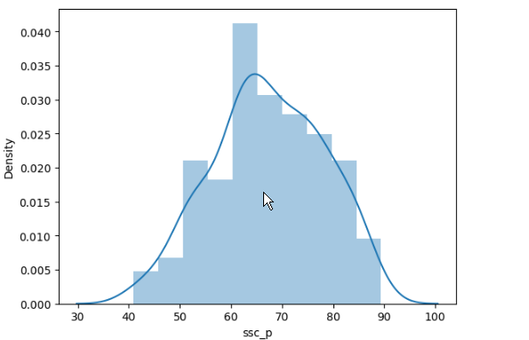
This the preprocessed dataset

This is the normal distribution graph

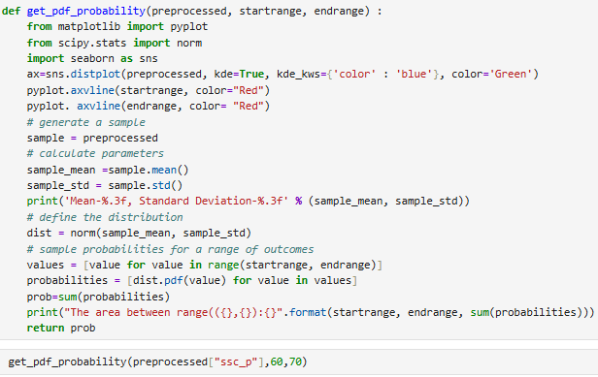
This is Code for probability distribution graph
Explanation of code:
- First we the importing the required libraries.
- Next we writing code for drawing this normal cure with colour differentiation.
- pyplot.axvline This line indicates the vertical line for probability
- Next mean and stranded deviation calculation part and print the calculation
- Next with using inbuilt function we calculation normal distribution
- Next use one line inlier for loop we take value one by one inside for calculation
- By using pdf inbuilt function we passing the value to take probability summation and printing for graph below will give graph for reference.
